North Walkden Primary School Knowledge Organiser
Subject: History | Term: spring | Year Group: 5  Crime and Punishment  Romans- Present Day  793ad - 1066 | NC Link: a study of an aspect or theme in British history that extends pupils’ chronological knowledge beyond 1066
Sir Robert Peel 1788-1850
Henry VIII 1491-1547

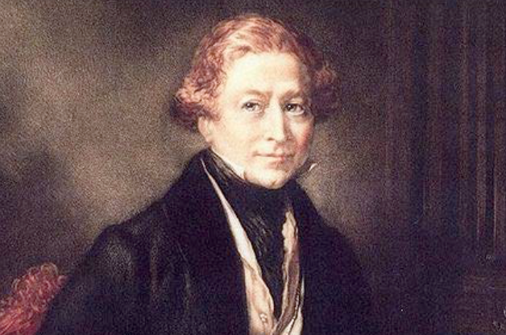
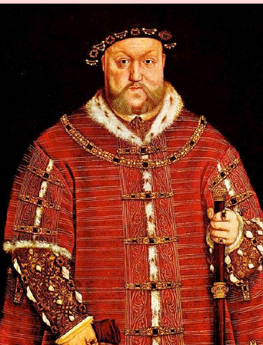
Significant People
In 1605, Guy Fawkes was caught red-handed with the gunpowder he planned to use to blow up the Houses of Parliament. There followed an investigation, interrogations and trials. Eleven of the thirteen men were hanged, drawn and quartered for treason.
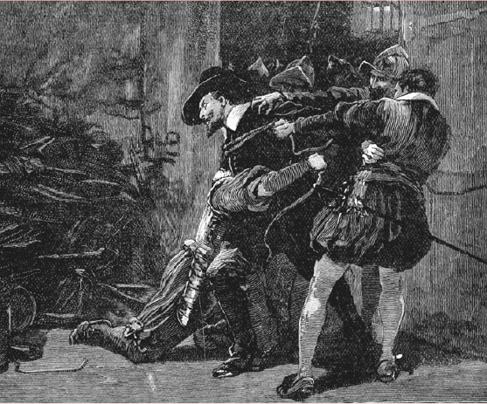
Norman Stocks
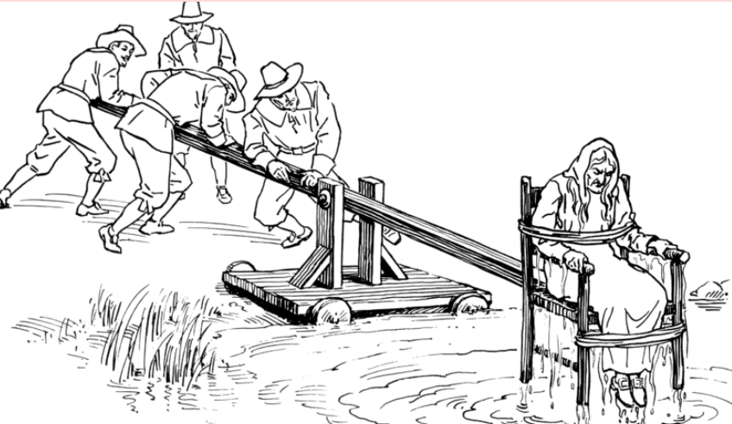
Tudor Executions
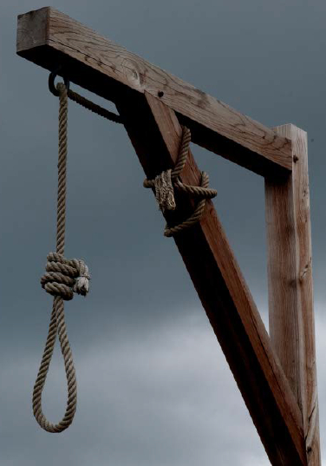
Victorian Transportation
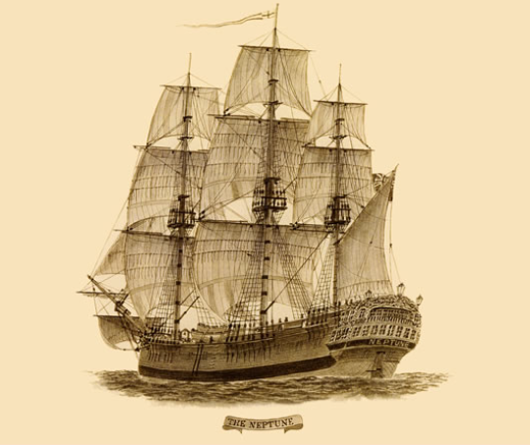
Types of Punishment through History
21st century electronic surveillance
Roman Crucifixion
Viking Weregild
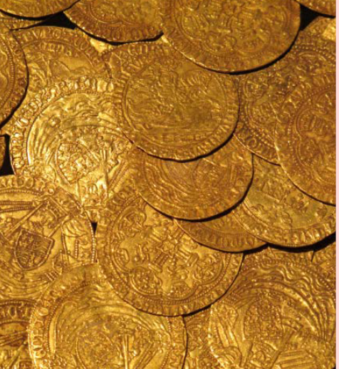
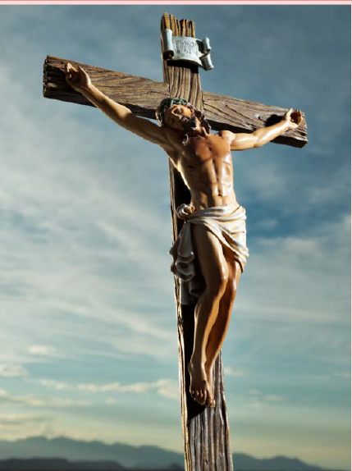

Key Facts
Romans developed laws for citizens and a legal system. Like today, defendants were presented before a judge and jury and were allowed to give evidence in their defence.
Throughout history, many crimes have been punishable by death, from the Romans’ crucifixion to the death penalty in some US states today.
When Henry VIII became head of the Church of England, he closed Catholic monasteries which used to help poor people. This meant that poor people had to resort to crime to feed themselves.
The Victorian era witnessed the introduction of the police force. Sir Robert Peel (born in Bury) set up the first real police force in London and passed the first Metropolitan Police Act in 1829.
Glossary of Vocabulary
Jury – a group of people who listen to all the evidence and decide if someone is guilty or not.
Judge – a person who is charge of a serious trial and decides what punishment a criminal gets
Trial – a meeting where all the evidence is read out and presented to decide if someone is guilty or not.
Lawyer – a person who decides to persuade the jury that person did or didn’t commit a crime.
Magistrate – a person who is in charge of a trial that’s not as serious.
Transportation – a punishment that meant being sent to live in America or Australia to work very hard.
Pillory – a punishment that meant being put in stocks so people could throw things at you.
Prior Learning
Children have learnt the chronological history of Britain from prehistory, Roman invasion to Anglo-Saxons, Picts and Scots and Vikings up to 1066.

A Famous Criminal in British History

