North Walkden Primary School Knowledge Organiser
Subject: History | Term: Spring | Year Group: 4 | NC Link: Britain’s settlement by Anglo-Saxons and Scots
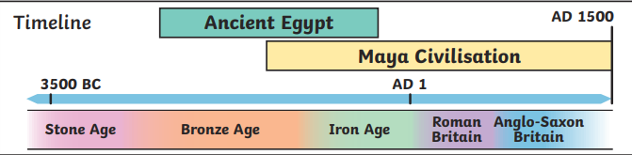
Who was buried at Sutton Hoo?

Where did they come from?

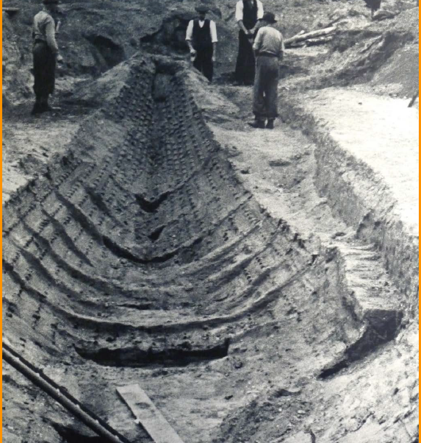
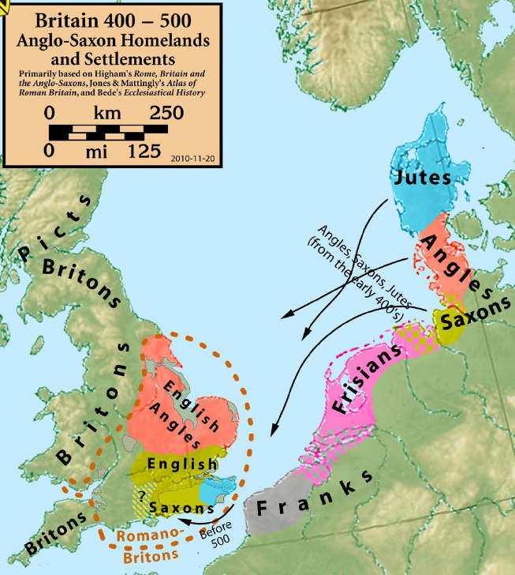
Key Facts
Anglo-Saxons originally came from Denmark in search of land for farming.
They battled with Picts and Scots for their land but they didn’t win.
Anglo-Saxons devised the 7 kingdoms of England.
Anglo-Saxons arrived as Pagans but converted to Christianity and this became the main religion.

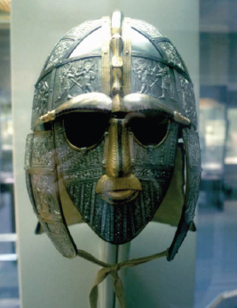
Anglo-Saxons
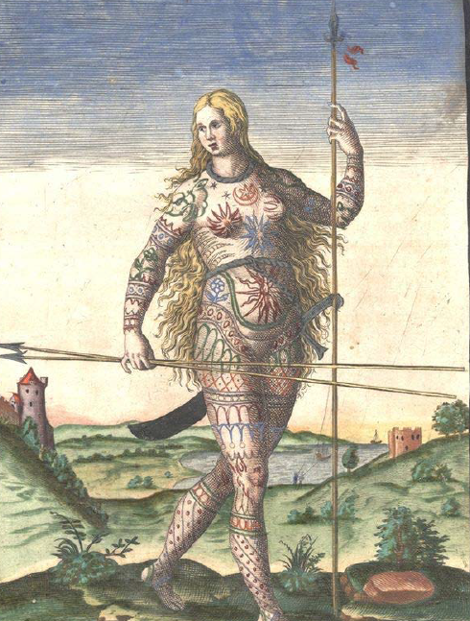
Picts
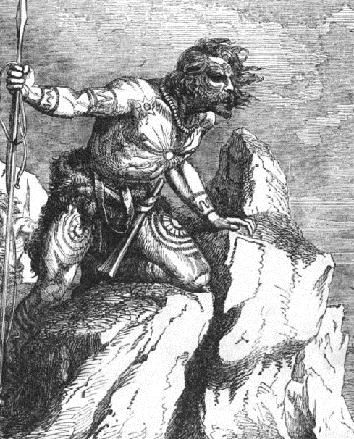
Scots
Anglo-Saxon Kingdoms
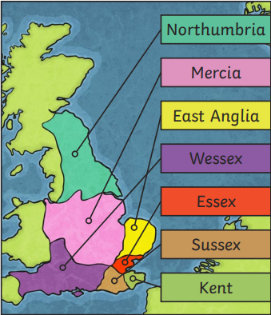

Glossary of Vocabulary
Pagan – an ancient religion which worshipped many gods. When the Saxons first settled in Britain, they were Pagan but then changed to Christianity.
Sutton Hoo – a grave site of an Anglo-Saxon king in England.
Runes – ancient writing system and alphabet used by Anglo-Saxons
Migration – the movement of people from one place to another
Ages – a period of time when a particular power or people were in the majority
Picts – tribes originally from Scotland who were feared
Scots – tribes from Ireland who, like the Scots, were fierce and powerful fighters

Anglo Saxons
450AD - 1066
Prior Learning
Children have learnt about Prehistoric Britain from 12000-500BC (approx.).
Children have learnt about the Roman invasion of Britain from 43AD to 450Ad

