North Walkden Primary School Knowledge Organiser
Subject: History | Term: Autumn | Year Group: 3 | NC Link: a study of an aspect or theme in British history that extends pupils’ chronological knowledge beyond 1066
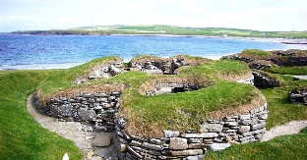
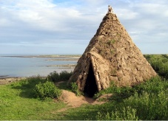
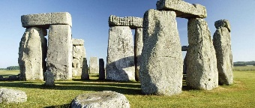
Key Skills
Use primary and secondary resources
Place Prehistoric periods on a timeline of British History
Explore a range of artefacts

Key Facts
Early humans (Palaeolithic Age) were hunter-gatherers. They built huts and moved around the country in order to farm.
Tribes defended their homes with forts and defences.
Neolithic people developed permanent tribes and communities.
Neolithic people built Stonehenge.
The Stone Age is followed by the Bronze Age, when humans began to use metal.
The Iron Age followed the Bronze Age. During this time, humans developed tools and weapons.

Skara Brae – A preserved Stone Age village in Scotland
Star Carr – a Mesolithic archaeological site in Yorkshire
Stonehenge – a famous prehistoric monument in Wiltshire
Significant Places
Iron Age 800BC – 500BC
Bronze Age 3,000BC – 800BC
Stone Age 12,000BC-3,000BC
Timeline
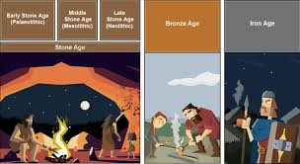
Stone Age – Iron Age
12,000BC-500BC
Glossary of Vocabulary
Hunter-gatherer – people who live mainly by hunting, fishing and foraging wild fruits
Palaeolithic – early Stone Age period
Mesolithic – middle Stone Age period
Neolithic – late Stone Age period
Settlement – a place where there are several people living in dwellings, like a small village
Prey – an animal that is hunted for food
B.C. – a period of time before Christ was born. E.g. 250BC is 250 years before Christ was born.
Archaeologist – people who discover artefacts or remains in the ground and use them to find out about the past
Artefact – an object made by humans which tells us about how they lived
Dwelling – a house or structure where people lived

Prior Learning
Children have an understanding that life was different a long time ago. Children can discuss changes in Britain within the last 100 years. Children can recall events that took place beyond their living memory.

