North Walkden Primary School Knowledge Organiser
Subject: History | Term: Spring | Year Group: 3 | NC Link: a study of an aspect or theme in British history that extends pupils’ chronological knowledge beyond 1066
Invasion Timeline
55BC: Julius Caeser wanted to extend the Roman Empire so he attempted to invade Britian but the Celts fought them back to France.
54BC: Caeser’s second attempt! He took bigger and stronger legions and successfully invaded parts of Britain.
AD43: New Emperor, Claudius, wanted to invade the rest of Britian. Most Celt tribes agreed to pay him taxes and obey his laws.
AD60: Boudica’s revolt. The Iceni tribe revolted against paying taxes, thousands died but eventually the Romans won.
AD122: Roman Emperor, Hadrian, built a wall between England and Caledonia to protect the Roman land from the Picts.

Prior Learning
Children have learnt about Prehistoric Britain from 12000-500BC (approx.).
Key Facts
Romans built straight roads to join towns.
The Romans had a strong, large army, which invaded Britain in 43AD.
Boudica (a Celt queen) revolted against the Romans and Emperor Claudius.
Romans invented central heating, plumbing and baths, some of the impressive buildings still remain today.

Women were not allowed to join the army and there were 2 types of soldiers: legionaries and auxiliaries.
Roman Army Organisation
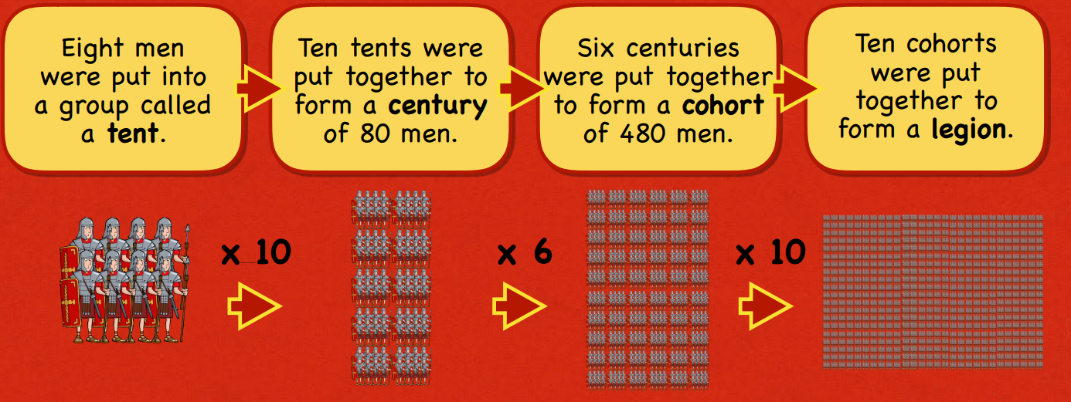
The Roman army was made up of legions which were organised in a very specific way. Each legion contained almost 5000 men.
Romans
40AD – 410AD
Glossary of Vocabulary
Celts – People living in Britain
Boudica – a Celt queen who revolted against the Romans.
Legion – a large section of the Roman Army, made up of 5000 soldiers.
Invasion – when an army forces entry of a place/country to take over
Emperor – the ruler of an empire
Roman Empire – The name used for the land that was controlled by the Romans, including parts of Europe, Middle East and North Africa.
Picts – tribes from Caledonia (Scotland)

