North Walkden Primary School Knowledge Organiser
Subject: History | Term: Autumn | Year Group: 1 | NC Link: changes within living memory. Where appropriate, these should be used to reveal aspects of change in national life
Glossary of Vocabulary
Decade - a period of time spanning ten years
20th Century – the years 1900-1999
21st Century – the years 2000-2099
Wooden – lots of early toys were made of wood like boats and train sets.
Plastic – lots of modern toys are made of plastic: dolls and ride on cars
Electronic – lots or toys are electronic now: talking teddies, Nintendo switch

Toy Timeline
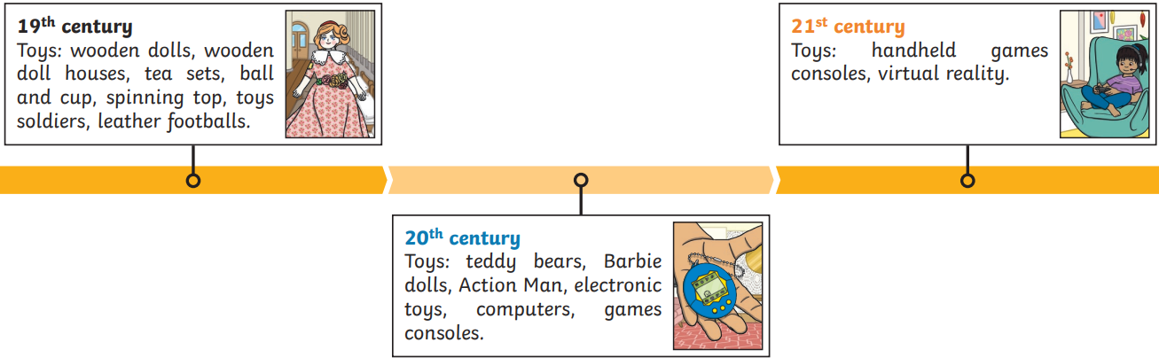
Key Facts
My grand-parents played with wooden toys and I play with electronic and plastic toys.
Toys used to be made out of wood and now toys are made out of plastic and can be electronic.
Most toys in the 21st century are electronic.

My grand-parents’ favourite toy was ____________.
My favourite toy is ________________________________.
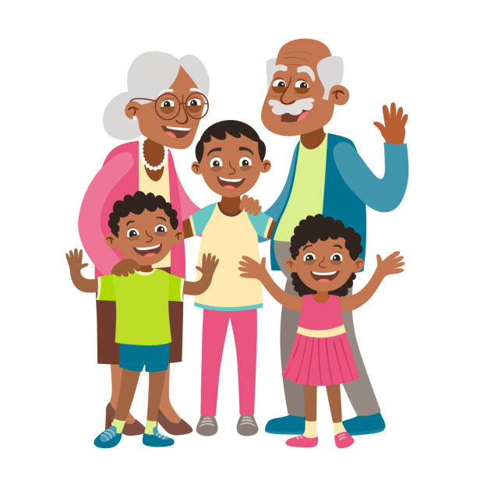
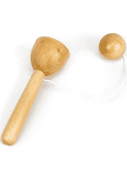
Types of Toys
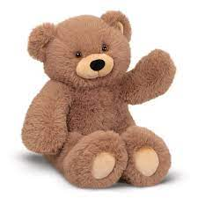
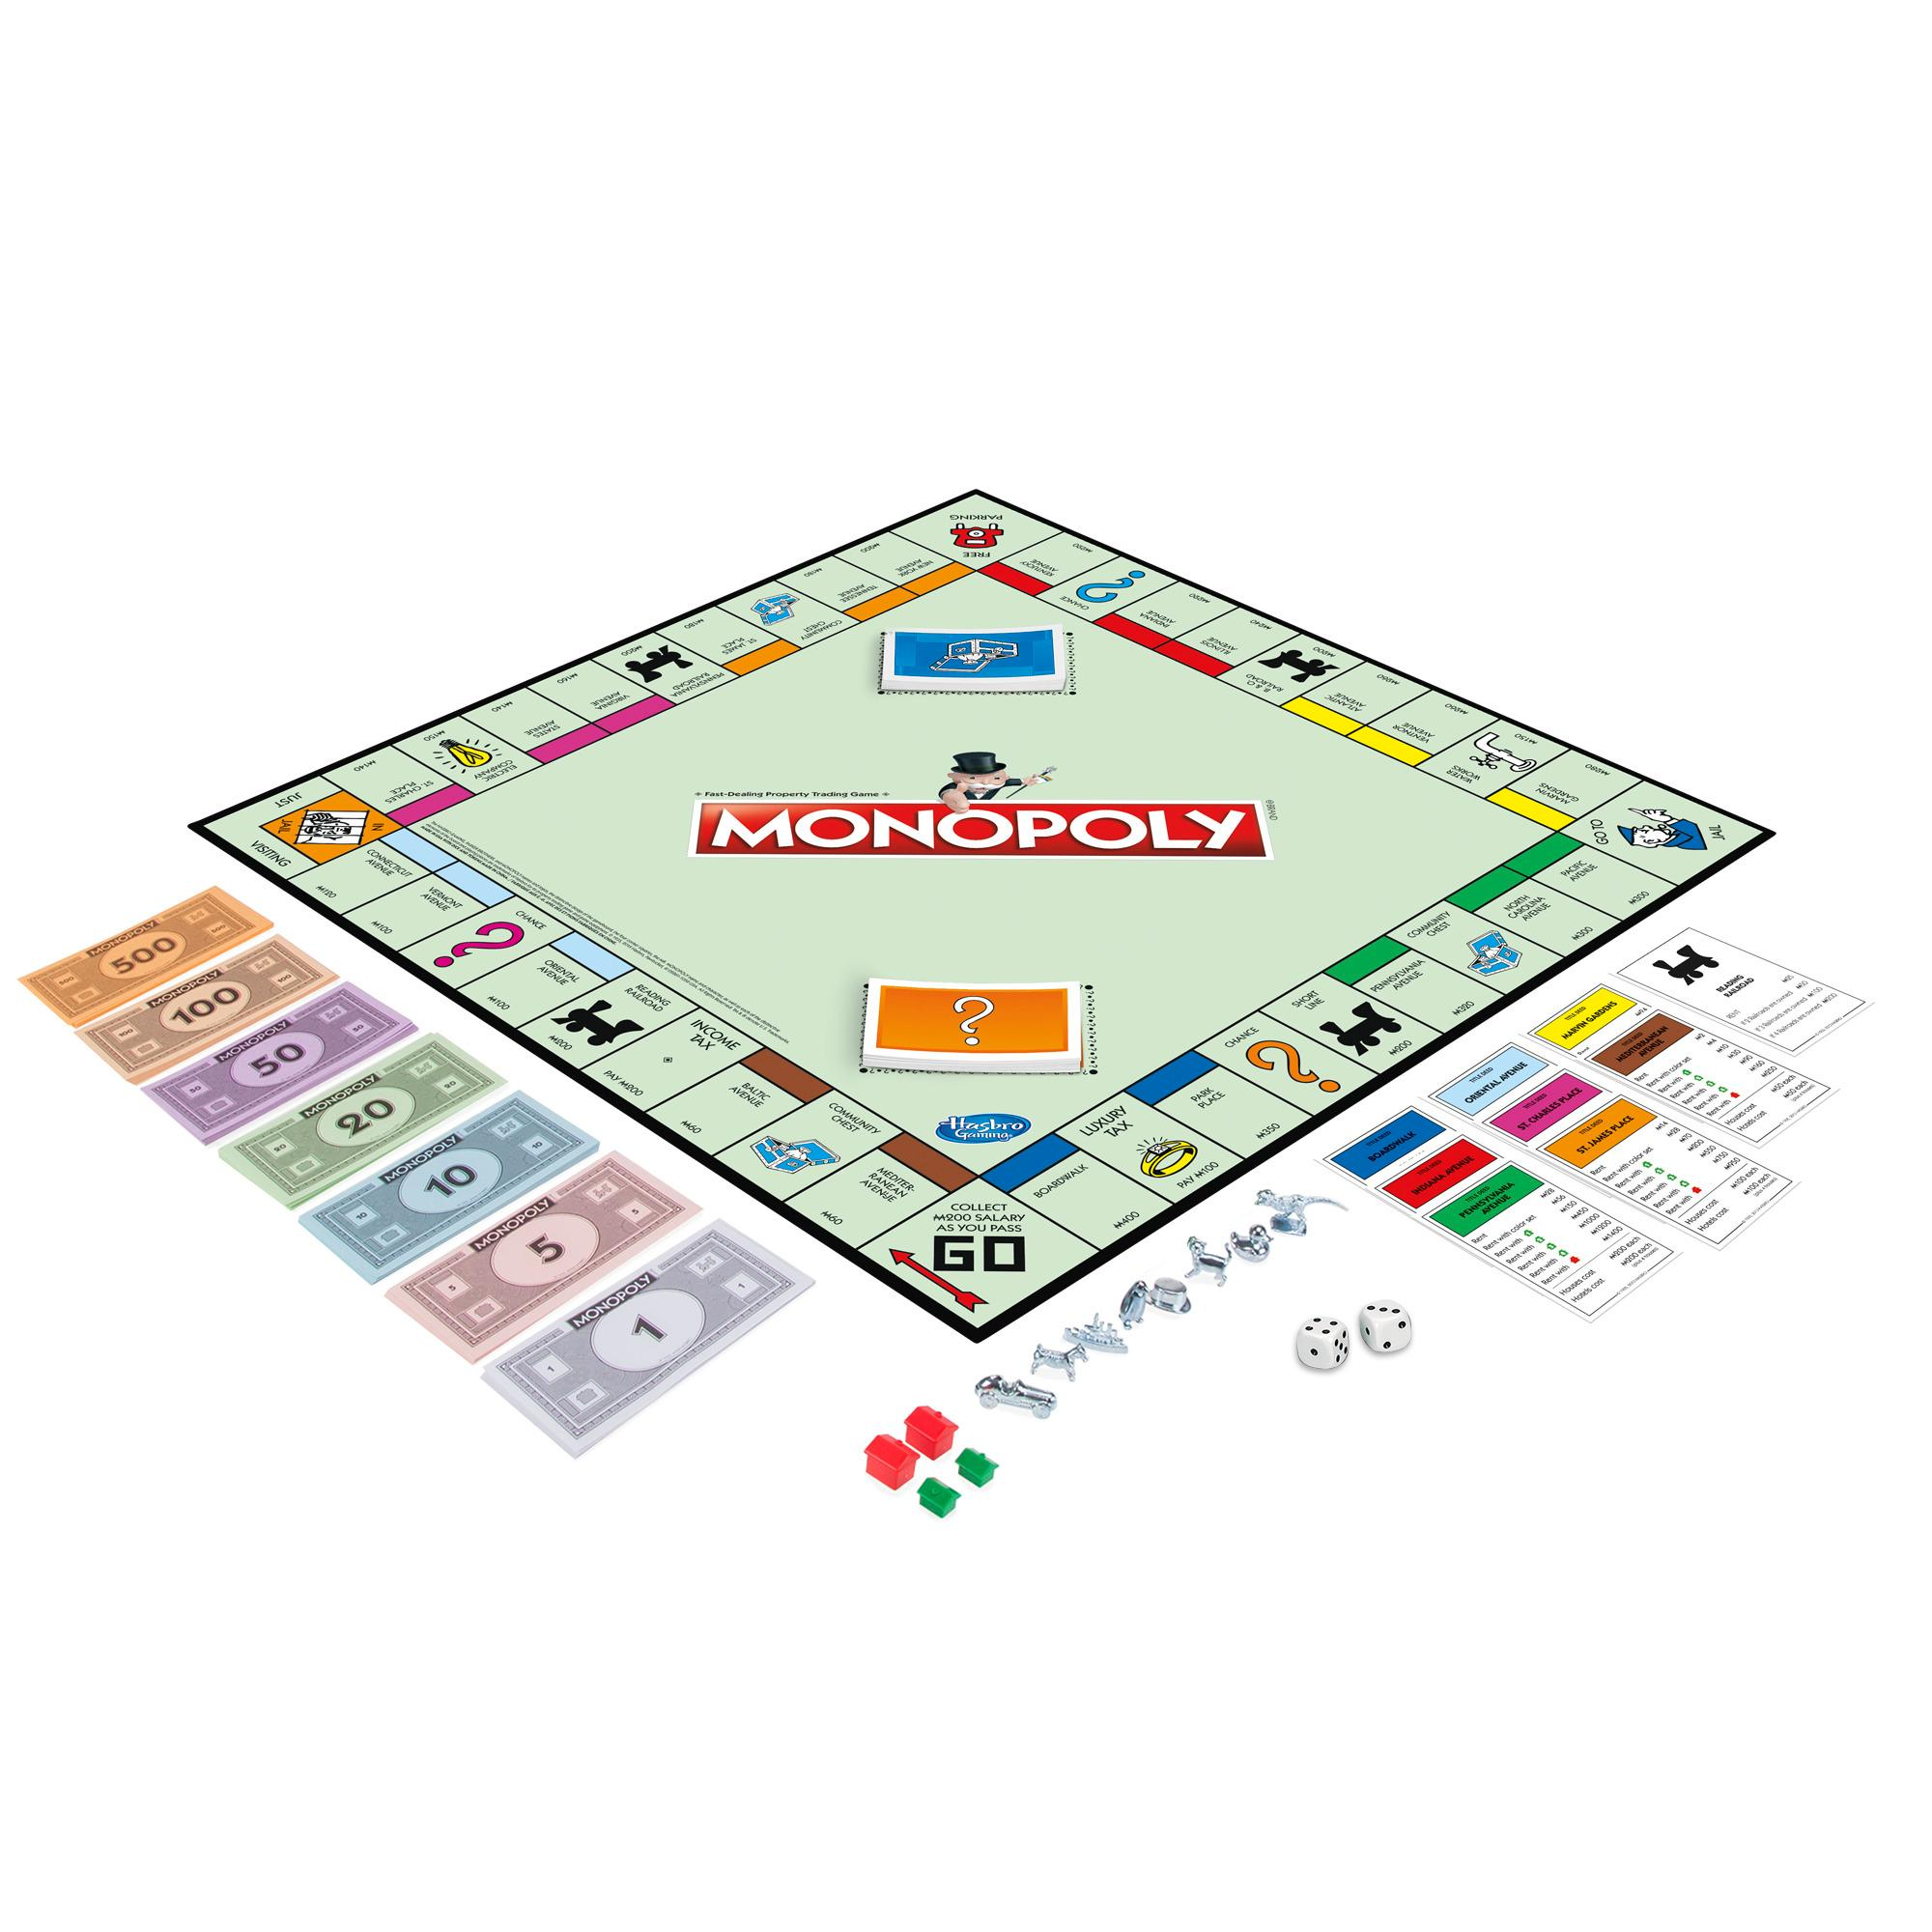
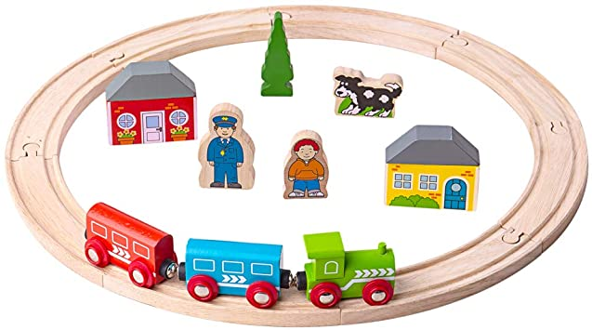
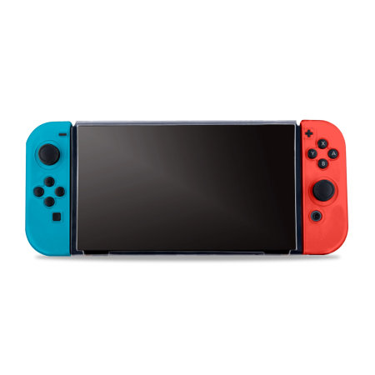
Toys
Past and Present
Prior Learning
Children have an understanding that life was different a long time ago. Children can recall some changes that have taken place within their living memory.

