



Knowledge Oganiser
Year 4
Animals including Humans

r
The Digestive System
Teeth
VOCABULARY
oesophagus- a muscular tube which moves food from the mouth to the stomach.
stomach- An organ where food is broken down with stomach acid.
small intestine- nutrients are absorbed and used by the rest of the body
large intestine- responsible for absorption of water. Faeces are formed.
rectum- Faeces are stored before leaving the body through the anus.

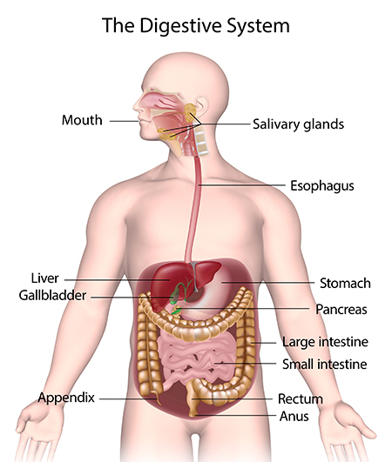
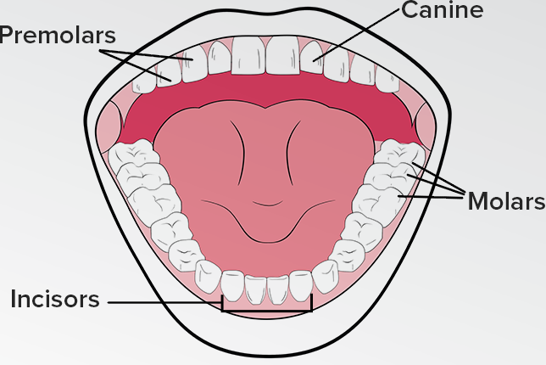
nnh
Rips and Tears
Holds and crushes

Grinds

Bites and cuts
Teeth Health
-Visit the dentist regularly.
-Brush teeth twice a day.
-Limit sugary food and drink.
-Use toothpaste with fluoride.


Key Knowledge: To sequence the main parts of the digestive system. Draw the main parts of the digestive system onto a human outline. Describe what happens in each part of the digestive system. To point to three different types of teeth in their mouth and talk about what each is used for. To demonstrate journey of food through body. Make a dental record, To explain teeth in animals and if they are carnivores, herbivores or omnivores.



Working Scientifically: Ask relevant questions.. Make careful observations and use a range of equipment. Gather, record and classify data. Record findings using scientific language, drawings, labelled diagrams. Identify similarities and differences. Use straightforward scientific evidence to answer questions to support findings.
• Interpret models to demonstrate how things work.
• Record findings using labelled diagrams

Animal Teeth
Different animals have different teeth depending on what they eat.
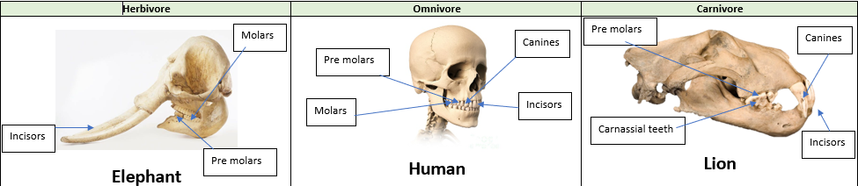
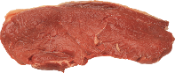



Eats plants and leaves
Eats plants, leaves and meat/other animals
Eats meat/other animals
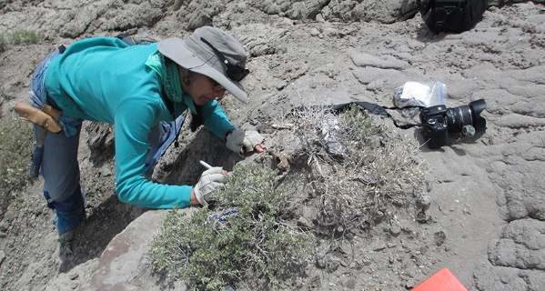
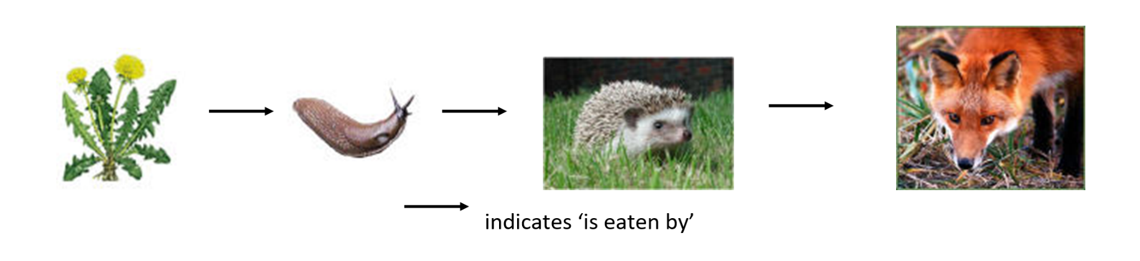



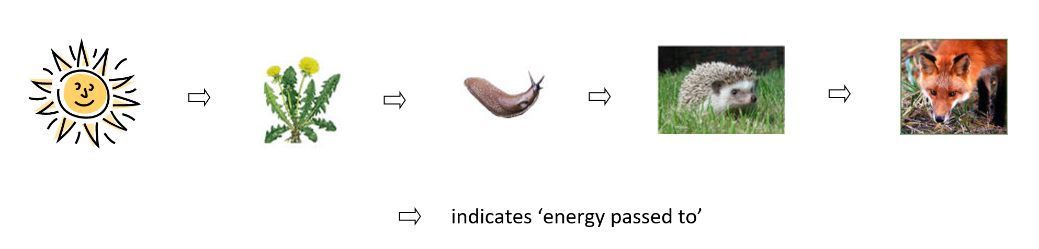
Food Chains
Producer
Primary consumer/prey
Primary consumer/predator/prey
Tertiary consumer/ Predator.
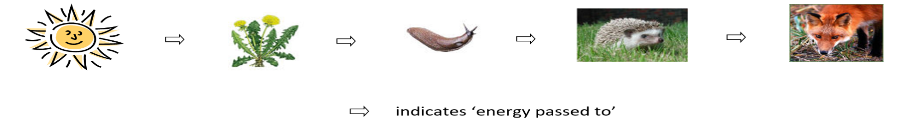
Scatologists study animal scat (faeces) to find out biological information about the animals they are studying.

