**Knowledge Organiser-**

**Year 3: Light**

Key Knowledge: To recognise we need light in order to see things and that dark is the absence of light. Light is reflected from surfaces. Recognise that light from the sun can be dangerous and that there are ways to protect your eyes. Recognise that shadows are formed when light from a light source is blocked by an opaque object. Find patterns in the way that the shadows change.

VOCABULARY

**light**- Light is a type of energy that makes it possible for us to see.

**source of light**- The sun and other stars, fires, torches and lamps all make light are examples of light sources.

**dark-** with little or no light

**absence of light-** refers to darkness. No or little light

**transparent**- allows light to pass through

**translucent-** allows light but not detailed shapes to pass through- diffuses light.

**opaque-** An opaque material does not let light through. It does not reflect light.

**shiny-** reflect light, typically clean and polished.

**matt-** dull and flat without a shine.

**surface-** outside part of uppermost layer of something

**shadow-** dark area or shapeproduced by an object coming between rays of light and a surface.

**reflect-** throw back light without absorbing it.

**sunlight-** light from the sun.

Facts

-Light travels in straight lines.

-Light from the sun can travel to Earth through a vacuum in 8 minutes.

-We need light to see.

-Light is a beam of energy.

-Plants turn light energy into food.

-Light travels at 300,000 km/second.

Light Sources

Reflection

|  |  |
| --- | --- |
| Natural | Artificial |
| A picture containing orange, oranges, close, croquette  Description automatically generated  Sun | A close-up of an object  Description automatically generated with medium confidence  Torch |
|  |  |
|  |  |

Light bounces off surface and changes direction as a result.

UV Light

How we see things

**



Prior Knowledge:

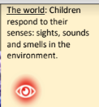 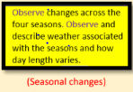

Sun Shadows

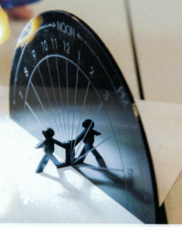

The earth spins once on its axis every 24 hours. As places on Earth spin into sunlight, the sun appears to rise in the East and travel across the sky until it sets in the West. As the height of the sun above the horizon increases during the morning, shadows cast by opaque, vertical objects (such as children!) reduce until they are smallest at midday, when the sun is highest. Our shadows lengthen again through the afternoon as the sun’s height in the sky reduces.

Shadows

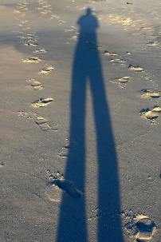

A shadow is made when an object blocks light since light cannot get to the area behind the object blocking it, a shadow appears.

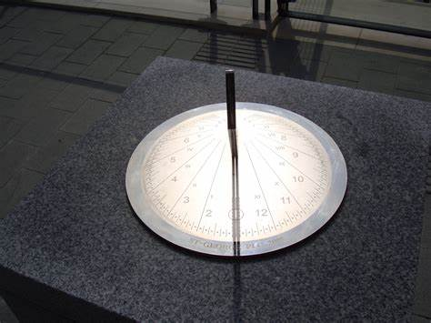

Sundials