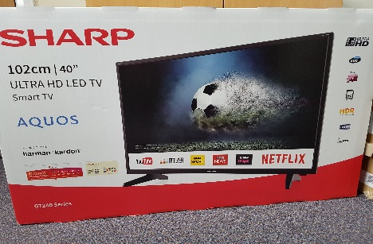
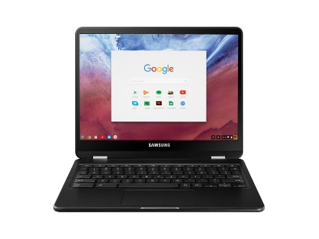
MEGA SUMMER RAFFLE
£2 per ticket
Prizes to be won:
- Sharp Smart 40” TV
- Chromebook (laptop) worth £200
- Premier Education – 2 x 5 days club / summer camp vouchers
- Powerleague Kids Party Voucher for 10 worth £184.50
- Meal for 2 – Cottage Tandoori – starter, main and wine
- LP Makeup Artist – Makeover – Full face with lashes
- Bounce Central – 4 Benny Bounce VIP tickets
- Jump Extreme tickets
- Ukulele
- Giant Cookie from Millie’s Cookies
- Fabulous fruit basket

Tickets on sale now from school – will be drawn at the summer fair
Thank you to the following for your generous donations: Home Estate Agents, Premier education, Powerleague, Cottage Tandoori, Laura Clark, Bounce Central, Jump Extreme, Front Row Music, Lisa McPhee – Millie’s Cookies, Worsley Fruit & Veg

