North Walkden Primary School Knowledge Organiser
Subject: History | Term: Autumn | Year Group: 5  Vikings vs Anglo Saxons  793AD - 1066  793ad - 1066 | NC Link: the Viking and Anglo-Saxon struggle for the Kingdom of England to the time of Edward the Confessor
Key Facts
Vikings arrived in England on longboats in the 8th century ready to take riches and land from whoever stood in their way. They came from Norway, Sweden and Denmark.
They arrived at Lindisfarne and robbed and looted the monastery – their longboats were perfect for attacking coastal towns. Vikings ultimately gained control of the Northeast of England – Danelaw.
Once unified, England was ruled by a Viking king – King Cnut in 1016.
Edward the Confessor’s death led to the Battle of Hastings. Three men claimed they should take the throne: Harold Hadrada, William Duke of Normandy and Harold Godwinson. William the Conqueror won.

Viking Life
Farms – Vikings loved to farm and kept cows, pigs and sheep for their wool, milk and meat.
Houses – A straw roof, wattle and daub for the inside of the walls, made of stone or wood on the outer.
Jewellery – worn to show off how rich they were
Pagans – they arrived as Pagans but converted to Christianity. Pagans worshipped many gods
Sagas – rhymes and stories about battles and monsters.

Glossary of Vocabulary
Danegeld – a tax paid by English/Anglo-Saxon kings to save Viking raiders savaging their land.
Raid – a surprise attack in order to rob/loot.
Longship – a long, wooden, narrow boat used by the Vikings
Resistance – a force that opposes/stops movement
Danelaw – the northeast of England, where the Vikings occupied
Normans – a group of people descended from Norwegian Vikings, living in France.

The Vikings were brilliant ship builders who built longboats that could sail right up onto the shore. They were built out of wood and made waterproof with tar and pine needles.
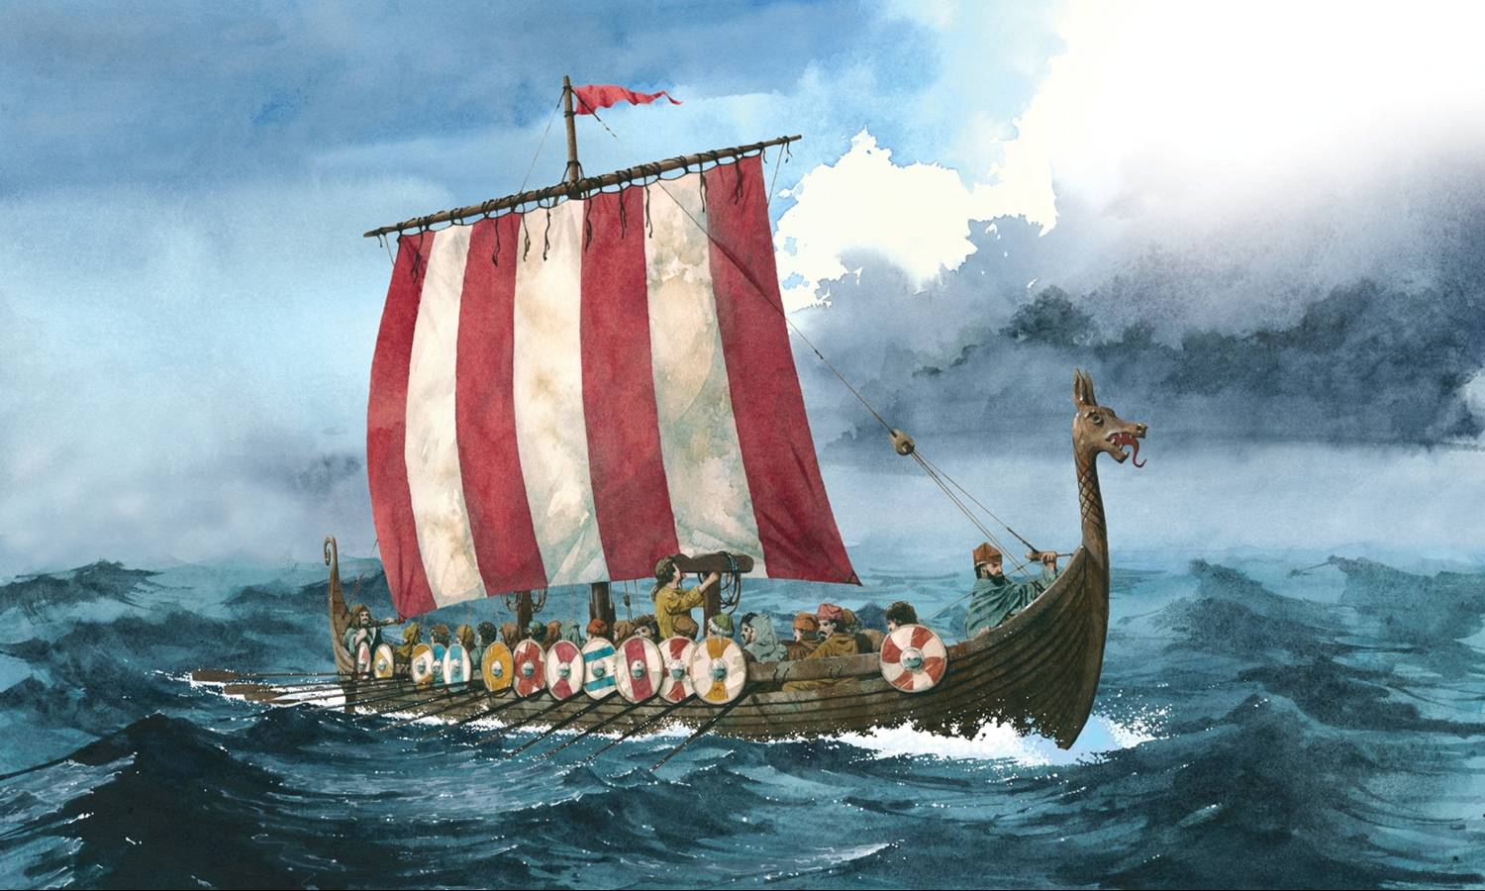

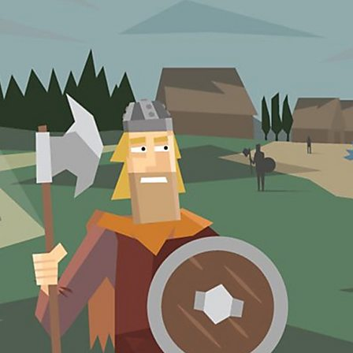
Prior Learning
Children have learnt the chronological history of Britain from prehistory, Roman invasion to Anglo-Saxons, Picts and Scots.
Significant Kings
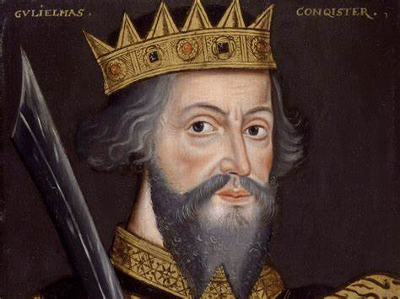
William the Conqueror
1066 - 1087
Edward the Confessor
1042 - 1066
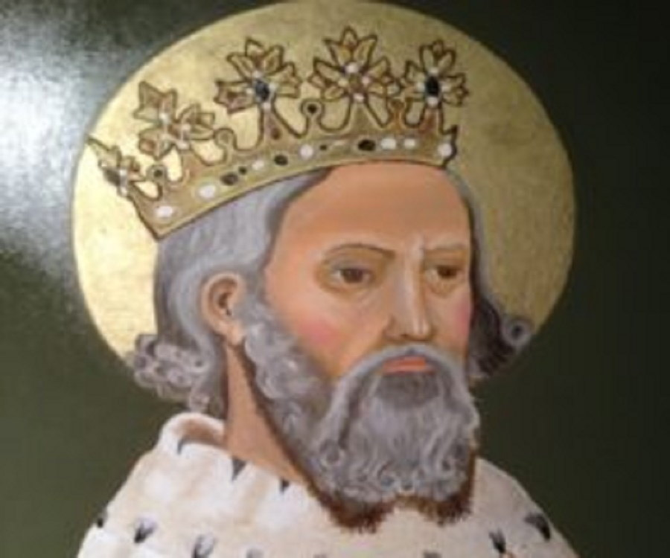
King Cnut
1016-1035
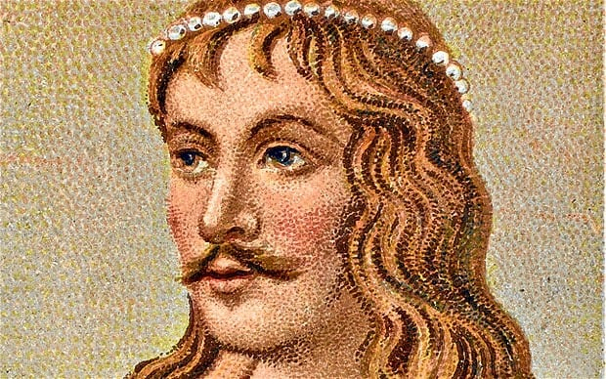
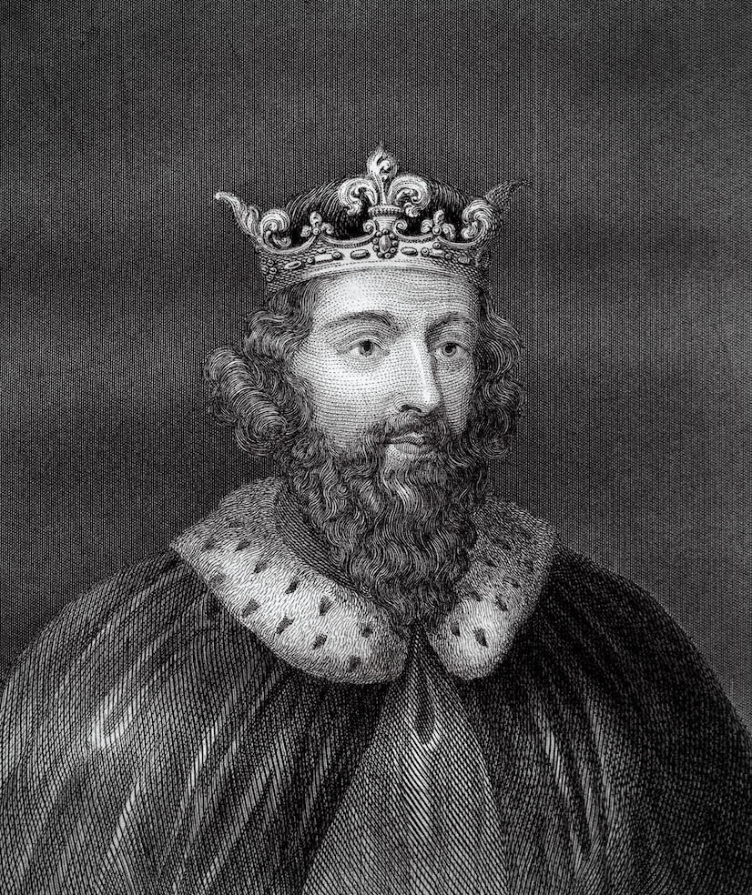
Alfred the Great
886-899

