North Walkden Primary School Knowledge Organiser
Subject: History | Term: Autumn  Ancient Egypt  3000BC – 395AD  Prior Learning  Children have been taught an overview of some of the first civilisations and studied their writing systems, mathematical findings and inventions. | Year Group: 4 | NC Link: the achievement of the earliest civilisations – an overview of where and when the first civilisations appeared and a depth study of one of the following: Ancient Sumer; the Indus Valley; Ancient Egypt; the Shang Dynasty of Ancient China
Glossary of Vocabulary
Tutankhamun – a ruler known as the ‘boy king’ when he became a pharaoh aged 9. His tomb was discovered by Howard Carter and contained over 3000 treasures.
Pharaohs – rulers of ancient Egypt
Hieroglyphics – a writing system that used pictures and symbols instead of letters
Sarcophagus – a decorated, stone coffin
Mummification – the process of preserving the body after death
Tomb – a large, underground enclosure used for burying the dead
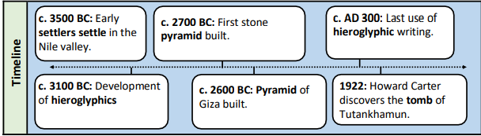
Howard Carter
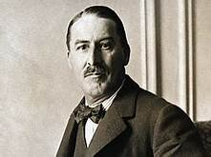
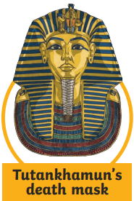
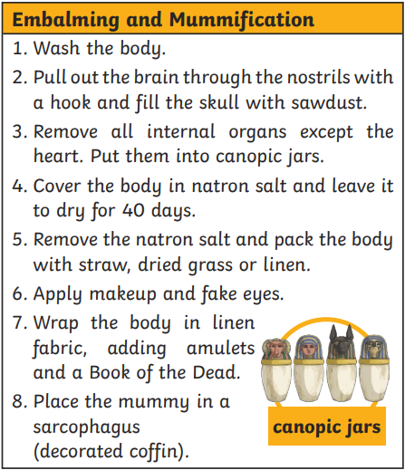
Key Facts
Ancient Egyptians used a process called mummification to preserve dead bodies because it was believed that the body would be needed in the after-life.
Ancient Egyptians built pyramids: amazing stone structures which they built as tombs for pharaohs.
In 1922, Howard Carter (an English archaeologist) found Tutankhamen’s tomb after years of searching. No one had been in the tomb for over 3000 years and lots of treasures were found in there too.
Most ancient cities developed around the River Nile. The Nile was a life source for Ancient Egyptians and enabled them to fish, farm, trade and carry out funerals.

