**Knowledge Organiser-**

**Year 3: Forces**

**Key Knowledge-** Give examples of forces in everyday life. Give examples of objects moving differently on different surfaces. Name a range of magnets and show how the poles attract and repel. Can draw diagrams using arrows to show the attraction and repulsion between the poles of magnets. Can use results to describe how objects move on different surfaces. Can use results to make predictions. Can use some classification to know some metals are not magnetic. Use test data to rank magnets.

**r**

VOCABULARY

**forces**- changes the motion of an object. Pushes and pulls in a particular direction.

**gravity**- a force which pulls things towards the centre of the Earth. Discovered by Sir Isaac Newton.

**push**- force which causes movement away from something.

**pull-** force which causes movement towards something.

**contact force**- requires contact to happen.

**non-contact force**- doesn’t require contact.

**attract-** causes something to move towards.

**Repel-** causes something to move away.

**poles-** Magnets have a North and South Pole.

**magnetic field-** magnets electric charge

An English mathematician, physicist, astronomer and author who is famous for his laws of motion, theory of colour and the discovery of gravity. Gravity is measured in Newtons (N)

Sir Isaac Newton

1643-1727

nnh

John McAdam

1756-1836

John McAdam was a Scottish engineer who modernised the way we build our roads.

.

His theories of motion and forces started at five years old when his father gave him his first compass.

Albert Einstein

1879-1955



Year 3

Forces

Friction

Forces are pushes or pulls.

Push and pull forces can make things start and stop moving, make a moving object change direction and change the shape of an object.

What is a force?

Friction is a force **between two surfaces** that are sliding, or trying to slide, across each other. For example, when you try to push a book along the floor, friction makes this difficult.

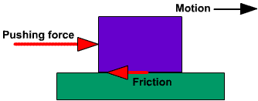

Magnets

Opposite poles attract. (Stick together)

The same poles repel. (Move away)

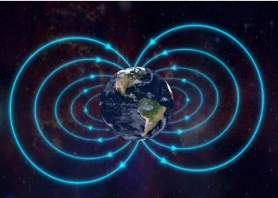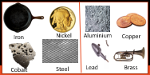

Magnetic Not Magnetic

Magnets have North Poles and South Poles.

Magnets can come in all shapes, sizes and strengths.

Magnets have magnetic fields.

The Earth is also a giant magnet. This is how compasses work.

