Key Knowledge: Can sequence the stages of a baby. Observe these changes. Can describe how animals change as they get older. Develops understanding of how insects change (more than a butterfly) through lifecycle diagrams. Can explain what humans and other animals need to survive- this could be through planning a trip to the moon or desert Island. Can describe how to keep clean and healthy. Has a good understanding of the food plate and understands ‘a healthy balanced diet’. Can create a diet for an athlete. Can adopt a menu to substitute food from the eat well plate. Understands the effect of exercise on the body.

**Knowledge Organiser- Year 2**

**Animals Including Humans**

**To stay alive, animals need:**

**Lifecycles**

VOCABULARY

**carnivore-** eats meat.

**omnivore-** eats plants and meat.

**herbivore-** eats plants

**offspring**- the child of an animal.

**lifecycle-** a series of changes that an animal passes through from birth to death.

**diet-** the food and water and animal needs.

**exercise**- a physical activity to keep your body fit.

**hygiene**- how clean something is.

**germ-** bacteria or virus.

**medicine**- a drug or other substance used to treat disease or other illnesses and symptoms.

**reproduce**- when living things make a new living thing of the same kind.

**Adults and their offspring**

Tadpole

Lamb Sheep

Flapper/Cygnet Swan (Pen/cob)

Frog

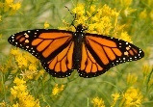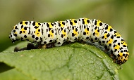

Caterpillar Butterfly

Rabbit

Rabbit kits (Kitten)

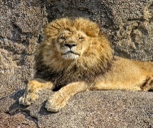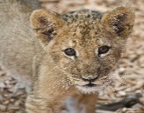

Lava/pupa Ladybird

Cub Lion

Kid Goat

Gorilla

Infant

**Example Lifecycles**

**Characteristics of Living Things:**

Movement

Respire (breathe)

Sensitive to the environment

Nutrients

Excrete (Get rid of waste/poo!)

Reproduce (have babies)

Grow.

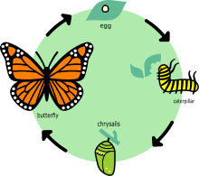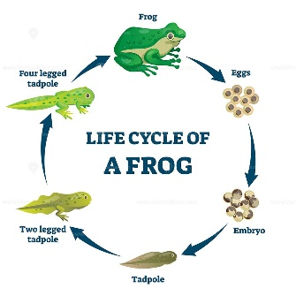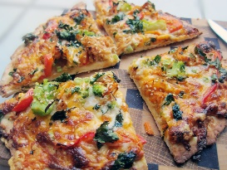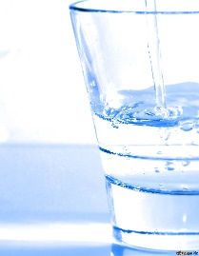

Food

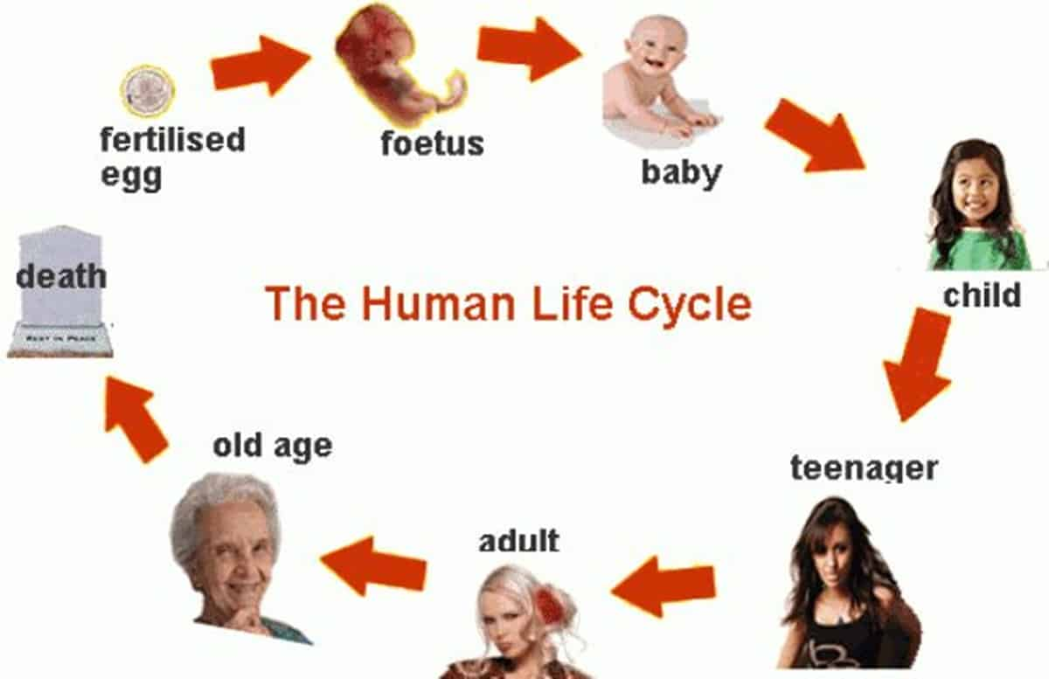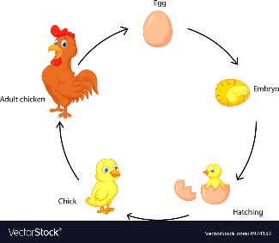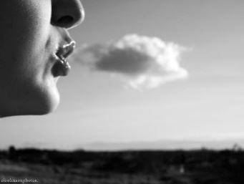

Water

Air



Year 2

Animals Including Humans

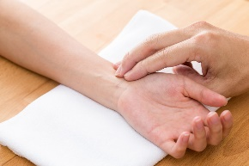

**Exercise**

**How to look after ourselves**

* We need to eat the right types of food and do the right amount of exercise.
* We need to drink plenty of water.
* To stop illness and infections spreading, we must be hygienic and keep ourselves clean.
* When we feel poorly, we may need to take medicines to help make us well again. We may need to see the doctor.
* We must look after our teeth and see the dentist regularly.

Our pulse rate measures how fast our heart is beating.

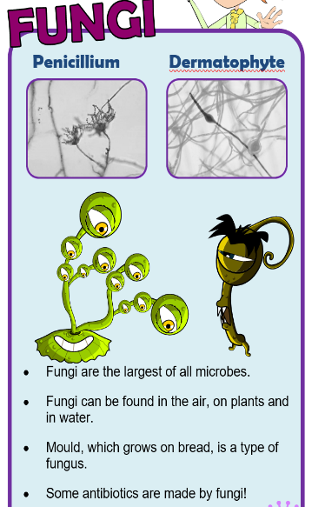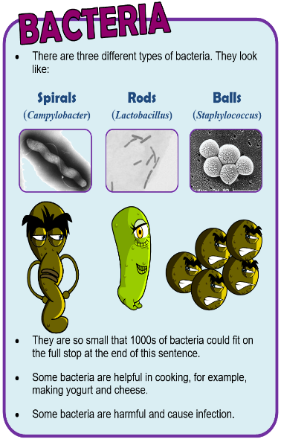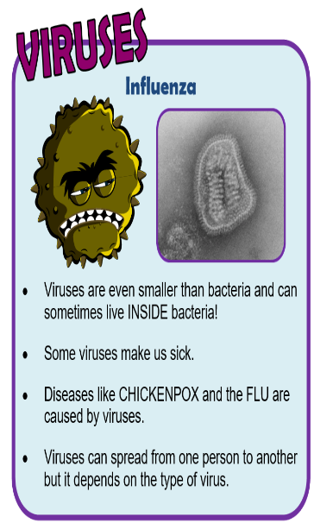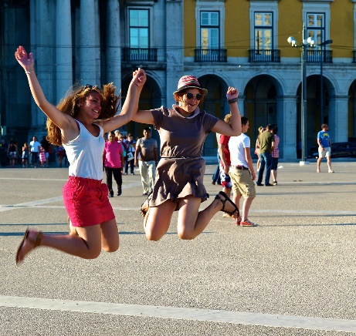

**Germs**

**Hygiene**

* We must wash our hands regularly with soap and water to get rid of germs (Bacteria).
* We must clean surfaces to kill harmful bacteria.
* Bacteria needs time, temperature, food, moisture and warmth to spread.
* Germs spread easily through the air- cough and sneeze into a tissue to stop the spread.

**A Balanced Diet**

Five Food Groups.

Fruit and Veg for our vitamins and minerals.

Bread, rice, potatoes, and pasta for our carbohydrates.

Milk and dairy food for our calcium.

Food and drink high in fats and sugars for energy.

Meat, fish, eggs and beans for protein

When we exercise our heart beats faster to pump oxygenated blood to our muscles.

This raises the pulse rate.