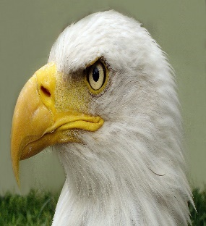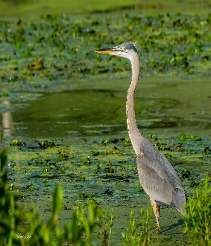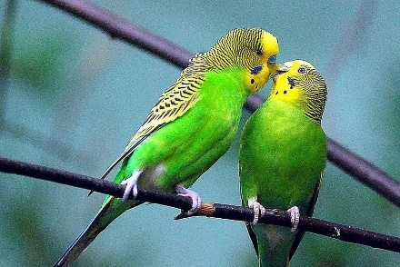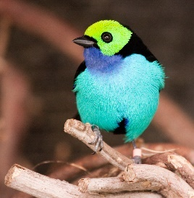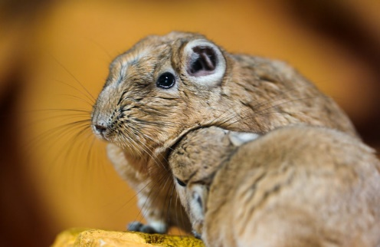

**Key Knowledge**: Can name a range of animals which includes animals from each of the vertebrate groups. Can describe the key features of named animals. Can label key features on a picture/diagram. Can write descriptively about an animal. Can write a ‘What am I? Riddle about an animal. Can describe what a range of animals eat. Can compare and classify animals.

**Knowledge Organiser- Year 1 Animals Including Humans**

VOCABULARY

**carnivore-** eats meat.

**omnivore-** eats plants and meat.

**herbivore-** eats plants

**amphibian-** live on land and water.

**reptile**- cold blooded with skeleton inside body, dry scales, or hard skin.

**bird-** warm blooded and lay eggs. Body covered in feathers.

**mammal-** warm blooded vertebrates.

**fish**- lives in water and has fins for swimming and gills for breathing.

**insect-** have bodies with 3 segments, protected by hard shell.

**minibeast-** small creatures without backbones.

**vertebrate**- has a backbone.

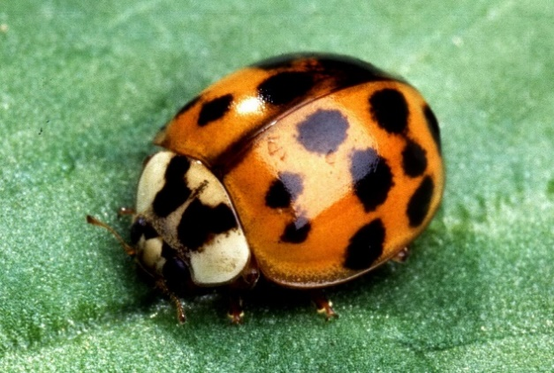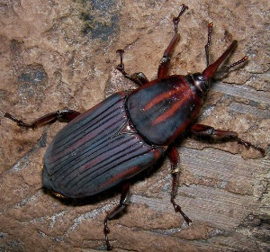

**BIRDS**

**Have feathers and wings.**

**Lay eggs.**

**Have two legs.**

**Ear holes instead of ears**

**Warm blooded.**

**Have a beak.**

**MAMMALS**

**Have hair or fur**

**Give birth to ‘live young’**

**Mammal mothers nurse their young with milk.**

**Have lungs and need air to breathe.**

**Mammals that live on land have 4 legs and ears that stick out.**

**Warm blooded.**

**INSECTS**

**Invertebrate (no backbone)**

**Have exo-skeleton**

**Segmented body**

**Lay eggs**

**Have antennae on head**

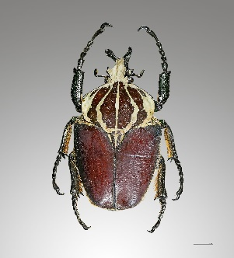

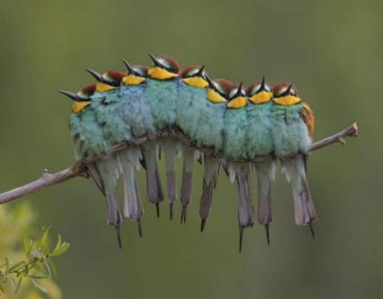

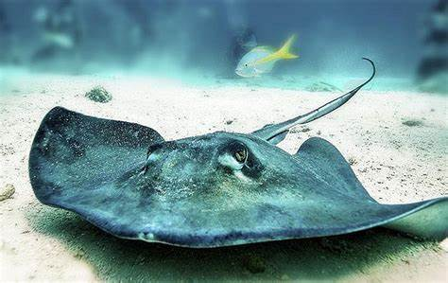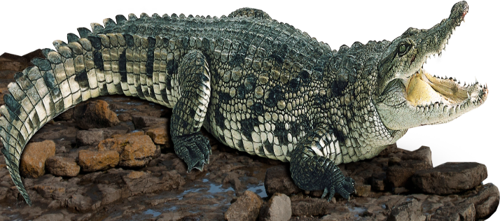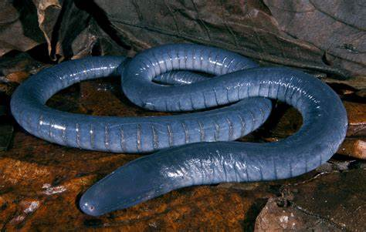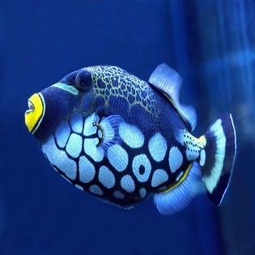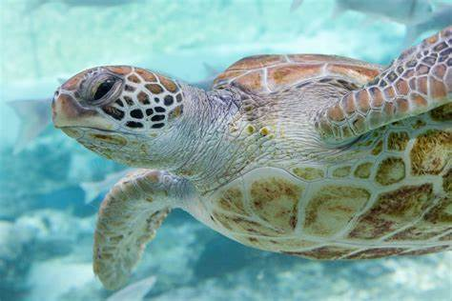

**REPTILES**

**Have scales not fur.**

**Have dry skin.**

**Usually lay eggs, sometimes live young.**

**Ear holes instead of ears.**

**4 Legs or no legs.**

**Cold blooded.**

**FISH**

**Breathe under water using gills not lungs.**

**Live in water.**

**Have scales and fins (no fur or hair)**

**Cold blooded.**

**Lays may eggs.**

**AMPHIBIANS**

**Live on land and on water.**

**Have webbed feet.**

**Breathe with lungs and gills.**

**Cold-blooded.**

**Moist smooth skin, no fur or hair.**

**Lay many eggs.**

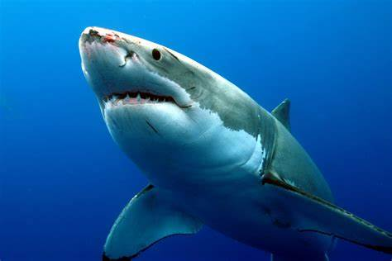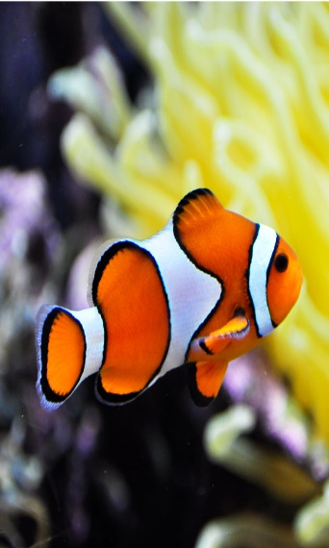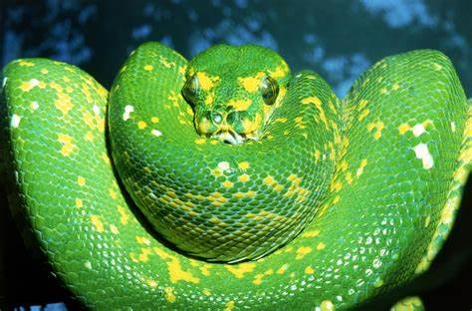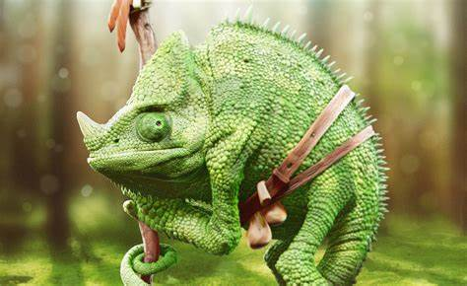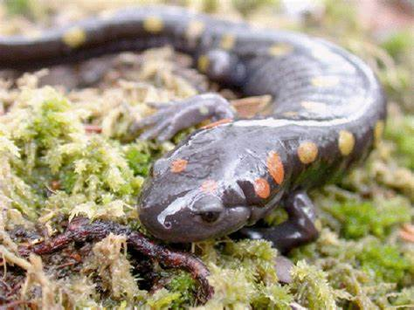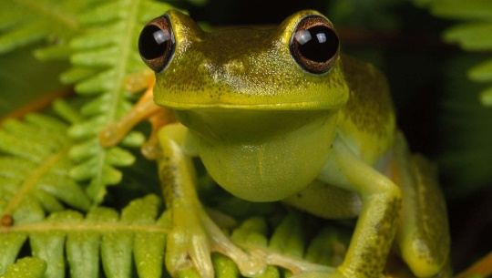

**There are lots of animal groups: there are also arachnids, vertebrate, invertebrate, arthropods and many more.**



Year 1

Animals Including Humans

VOCABULARY

**ears**- found on the side of your face to help you hear.

**head**- at the top of the body contains the brain.

**eyes**- On our face, helps us see.

**nose**- on the face- helps us smell.

**hands**- on the end of the arm, help us touch.

**skin**- biggest organ of the body, covers our skeleton.

**mouth-** On the face, helps us taste and houses the tongue and taste buds.

sweet, sour, bitter and salty- words associated with taste.

|  |  |
| --- | --- |
| Our Senses | |
| sight  Your eyes and light let you see things all around you. |  |
| smell  You smell using your nose. |  |
| hearing  Your ears let you listen to sounds. |  |
| touch  Your skill gives you the sense of touch. |  |
| taste  Your sense of taste comes from your tongue. |  |

head

ears

hair

eyes

mouth

hand

elbow

knee

foot

neck

shoulder

chest

stomach/

tummy

leg

toes